As our team is competing in Formula Student competitions, it is vital for us to know the state of the vehicle every single time while on track. Not knowing critical parameters like cell voltages and temperatures may result to severe problems that bring both safety and performance at risk. Thus, as a team we have implemented a wireless communication Telemetry system based on LoRa (**Lo**ng **Ra**nge) communication protocol to ensure that we monitor all those critical parameters live. By choosing this protocol we can achieve lots of information being sent on a distance over 500 meters.

**Step 1: Telemetry architecture**

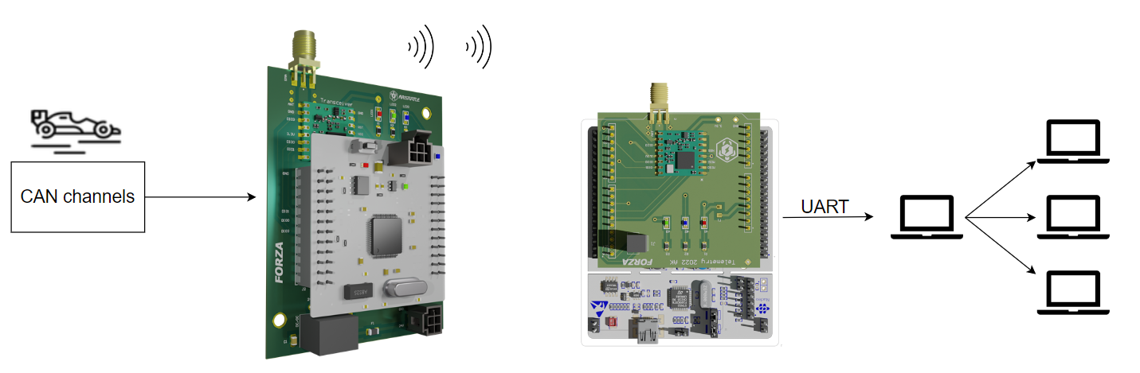

The system consists of one transmitter and one receiver. The transmitter is mounted on the car and is connected to the car’s CAN channels. It is responsible for collecting all the data from the car and for transmitting them wirelessly to the receiver which is connected to the user’s laptop. Then, the data are being transferred through serial communication to a self-developed Telemetry interface that visualizes them in a proper manner.

**Step 2: Hardware**

The transmitter subsystem consists of:

* 1 × STM32F446RE
* 1 × 2.5dBi Panel mount passive antenna
* 1 × LoRa 868MHz chip
* Power Supply: 24V through battery cells or Power Supply Unit

The receiver subsystem consists of:

* 1 × STM32F446RE Nucleo board
* 1 × 2.5dBi Panel mount passive antenna
* 1 × LoRa 868MHz chip
* Power Supply: From PC through USB

**Step 3: Schematic Designs**

Transmitter schematic:

Receiver schematic:

**Step 4: How to Order PCBs From JLCPCB**

Here, we would like to take this opportunity to express our gratitude towards JLCPCB for providing the PCBs and making this project a reality. You can order your own PCBs from JLCPCB by clicking on the following link: **jlcpcb.com/HAR**. First of all, you have to add a Gerber file. Gerber file is a file that is exported from the software that you design the PCB. In our case that software is Altium Designer. The next step is to select all the characteristics you require for your PCB. After that, you will have to add the remaining files, such as the BOM files and the pick and place files. Upload these files and you are ready to complete the order.

**Step 5: Interface**

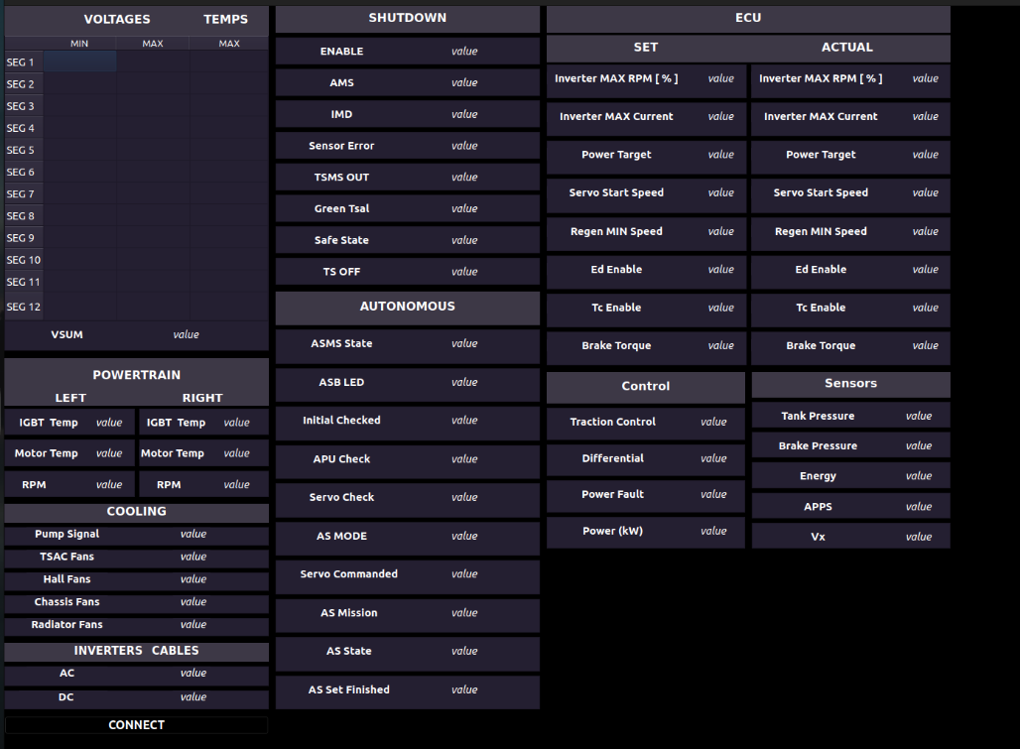

All the data that are transmitted, are visualized in a informative and comprehensive self-developed interface using PyQt libraries. Note that all the variables have been downsampled because in an interface we don’t need that much refresh speed as this will only be seen by a human’s eye.

**Step 6: Proof of concept**

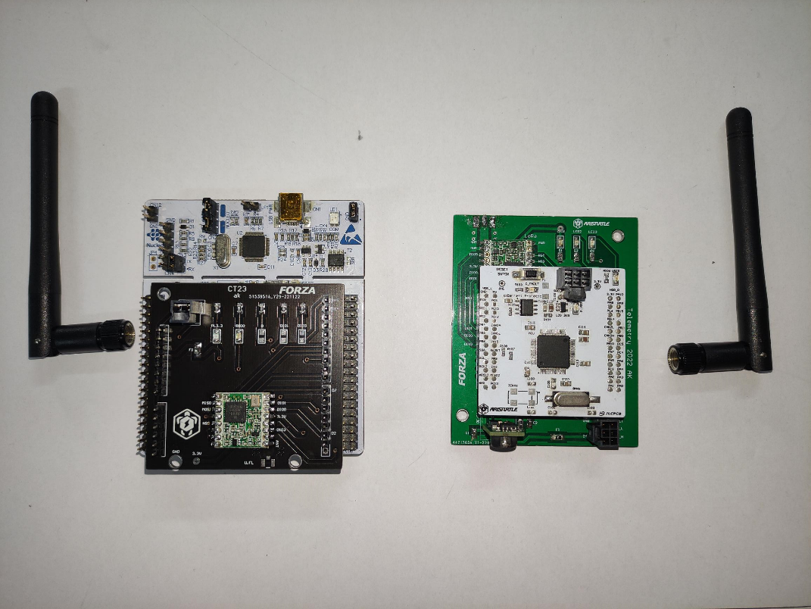

We have tested the system on track and validated that the transmitted payload is large enough (250 bytes) to cover all the variables that we need to monitor as well as that the maximum distance reaches approximately 500m in line of sight (LoS) making the choice of the communication protocol a suitable choice for robust long range data transmission.